Documentation
Website URL:
http://tldnc.co.uk/2025-2026/td2s/233753/riget-zoo-adventures/
Website Policies URL:
http://tldnc.co.uk/2025-2026/td2s/233753/riget-zoo-adventures/policies.php
Change made | Reason for the change | Pictures of changes (optional)
Changed the label on a navigation bar button from “Plan your visit” to “Plan your stay” | The label has been changed for clarity as, “Plan your stay” better describes that the button links to the hotel booking page | Mock-up design:  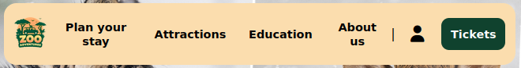    Modified element:
Changed the styling of the cards in the “New attractions” section on the “Homepage” to match that of the “Attractions” page | This has been done to maintain consistency of the styling across pages, making it easier for users to understand that they do the same thing
Changed the password hash in the database to being VARCHAR(255) instead of BLOB(127) | This has been done as the password_hash function in PHP returns a string (not bytes), which can be greater than 150 characters
Changed the database schema so that arrays are not used. Instead, each entry in the riget_bookings and riget_zoo_tickets tables contain an “email” field that is used to associate the entry with a user | This has been done to simplify the process of adding, updating, deleting, and retrieving hotel bookings and zoo tickets.
Changed the styling and layout of the page for booking zoo tickets to match that of the page for booking hotel stays | This has been done as now that development has started, I have realised that implementing the original design for the ticket booking page would have exceeded the project’s deadline. | Mock-up design:  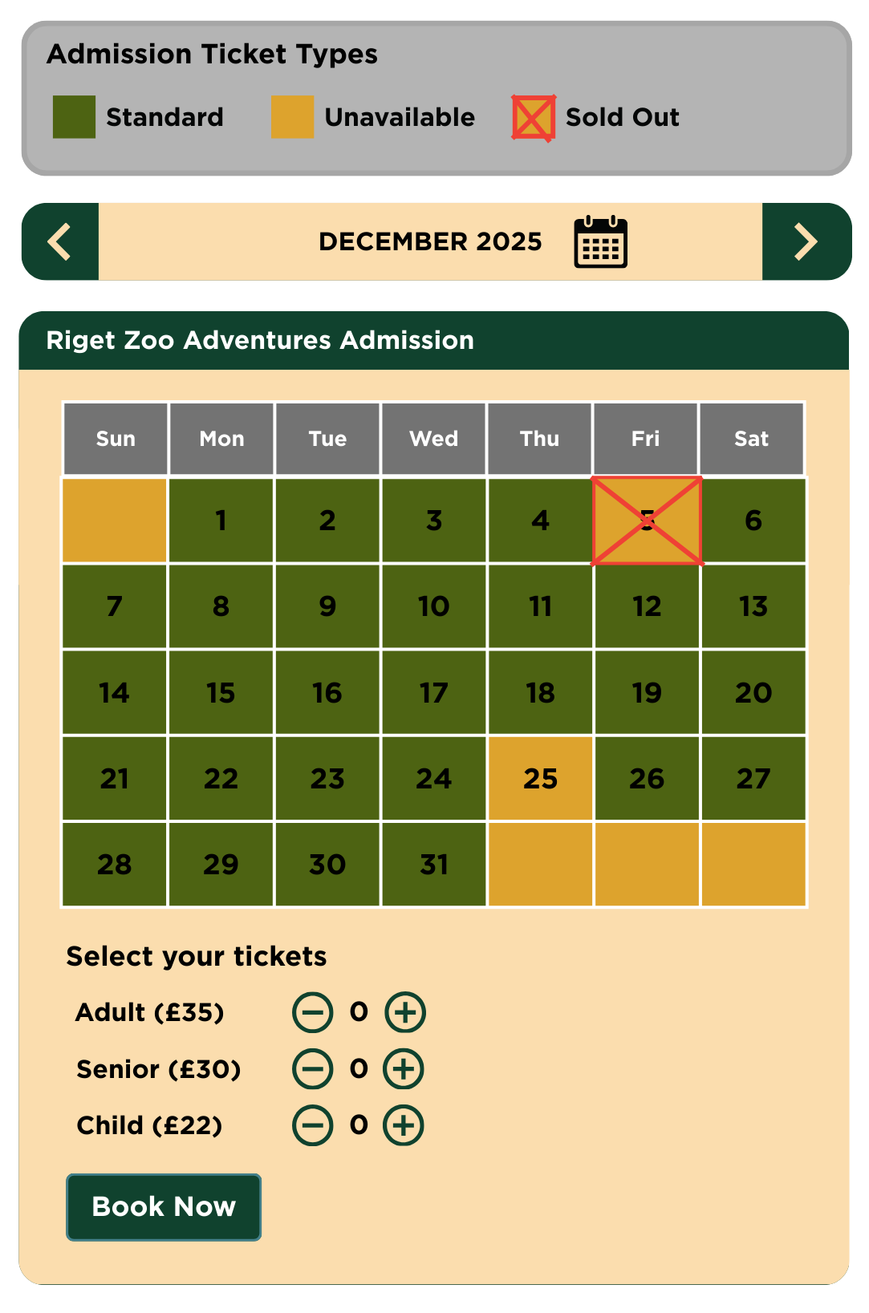  Modified element:  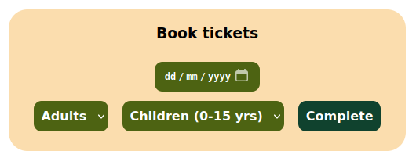
Account dashboard has very minimal styling | This has been done due to time constraints. I placed higher focus and priority on the functionality of the account dashboard – so that users would be able to see their bookings were successful – rather than styling, which can be updated later on once functionality is complete | Mock-up design:  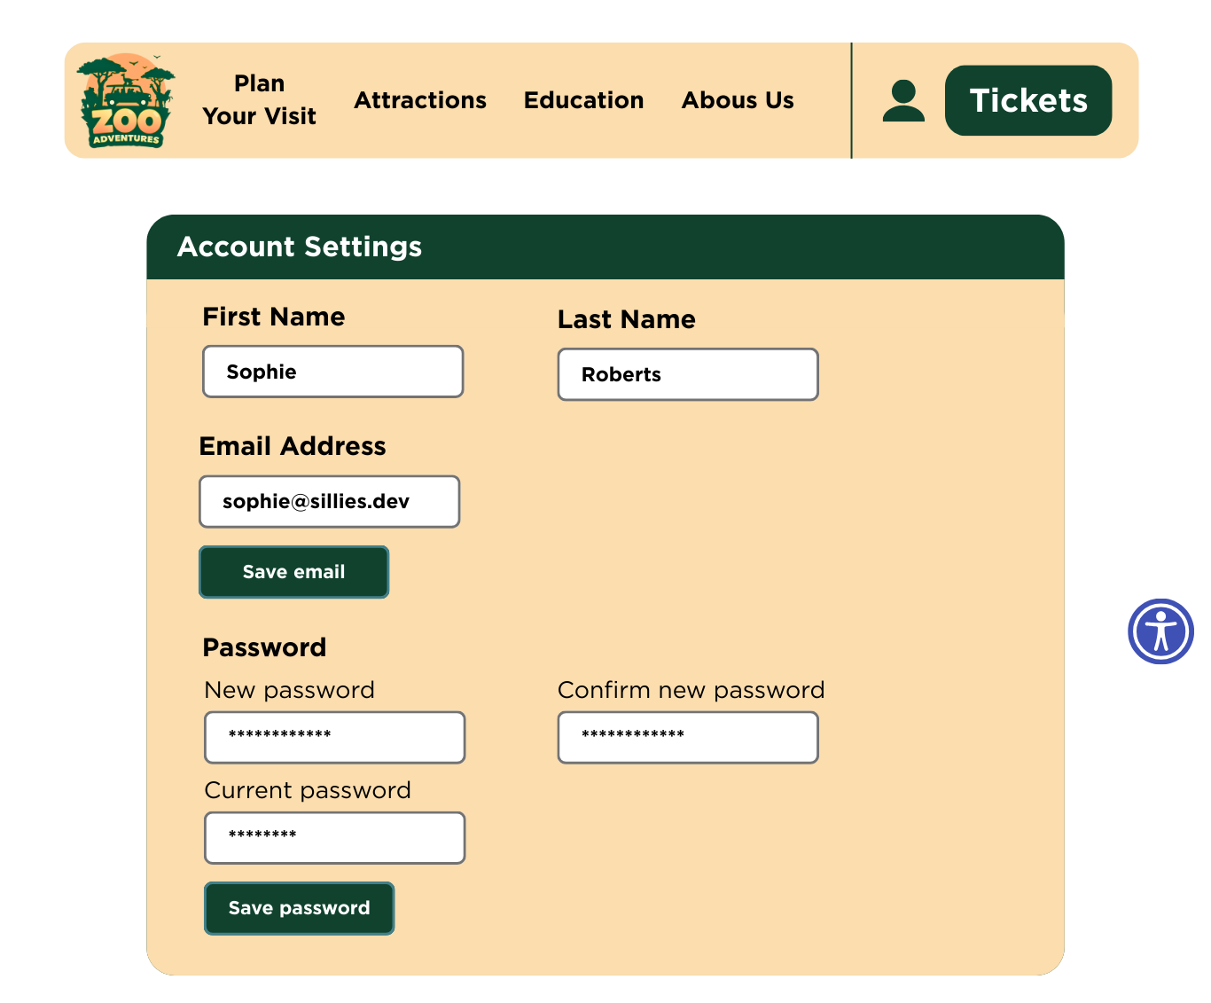  Modified element:  